**09/09/2020**

<INSURANCE AGENT>

<IAW0001>

Detail Level Design (SSAD)

**Record of Release**

|  |  |  |  |  |  |
| --- | --- | --- | --- | --- | --- |
| **Version No.** | **Modified By** | **Reviewed By** | **Authorized By** | **Release Date** | **Modifications Done** |
| 1 | Shreya Shetty | Shreya Shetty | Yashasvi Thakur | 12/09/2020 | Module Specifications, function specification |
| 2 | Yashasvi Thakur | Shreya Shetty | Yashasvi Thakur | 12/09/2020 | database, user interface design. |
|  |  |  |  |  |  |
|  |  |  |  |  |  |
|  |  |  |  |  |  |

**Table of Contents**

***1.0 Database Design / Class Design 3***

***2.0 Processes / State Transition Diagrams 3***

***3.0 User Interface Design 3***

***4.0 Module Specifications 3***

*4.1 Module Overview 3*

*4.2 Function Specifications 3*

*4.3 External Components Used 3*

# **Database Design / Class Design**

DATABASE_DESIGN

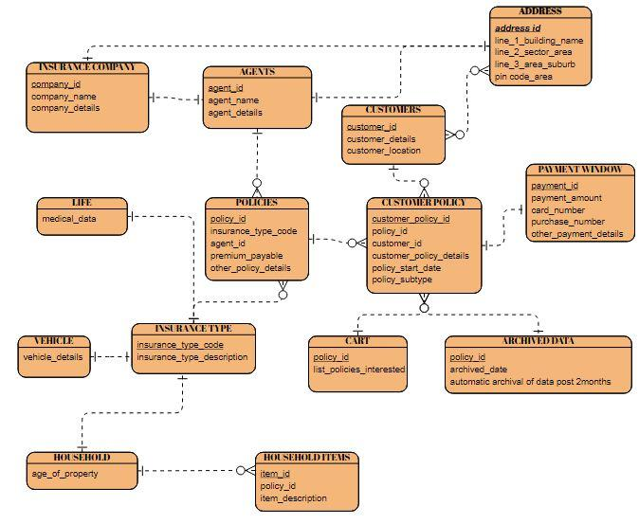

CLASS DESIGN

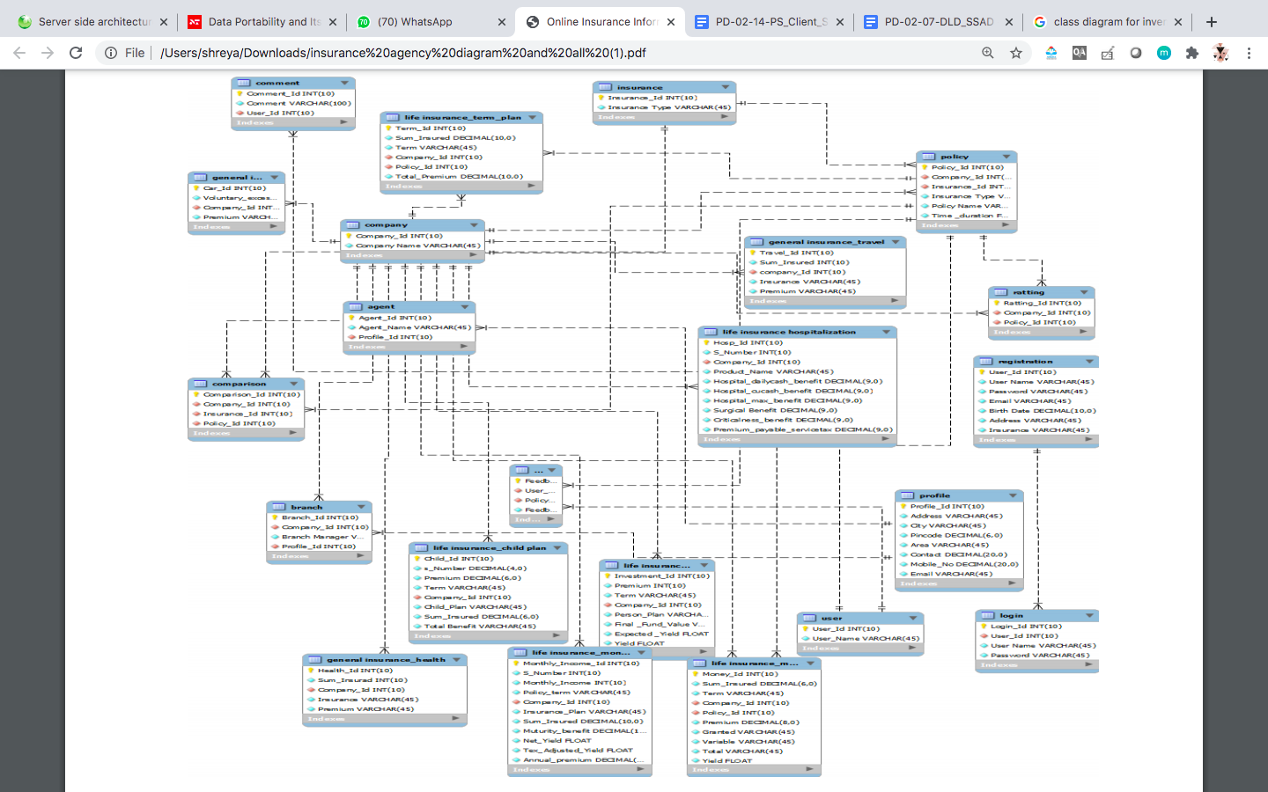

1. Type: RDBMS

2. Database Server : Oracle

3. Database was designed in accordance with the Requirement Specification Document (RS).

4. Software development follows an Iterative Model.

5. Efficient utilization of disk space by elimination of redundant and repetitive data.

6. Data accuracy and integrity maintained.

7. 100% data security is assured by keeping it password-protected. Each box in the Database Design Model represents an ***independent*** Database Design Table.

# **Processes / State Transition Diagrams**

# 

# **User Interface Design**



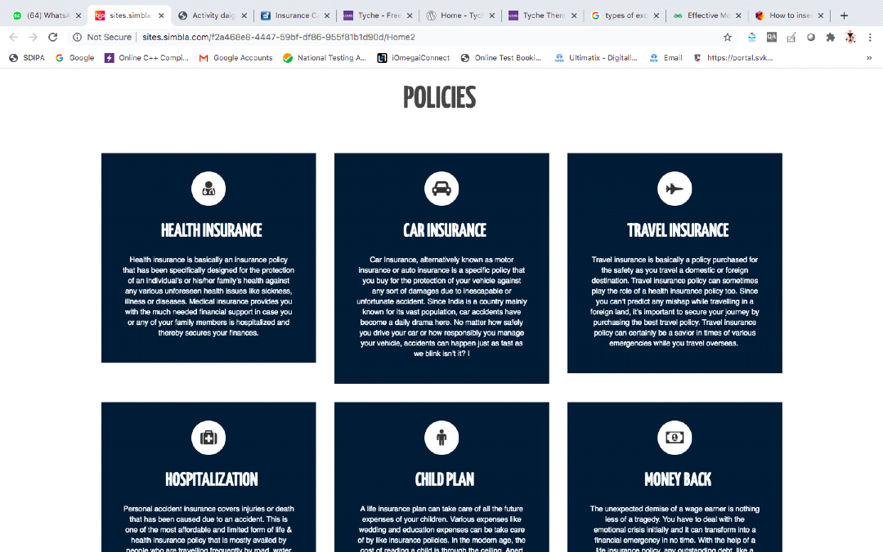

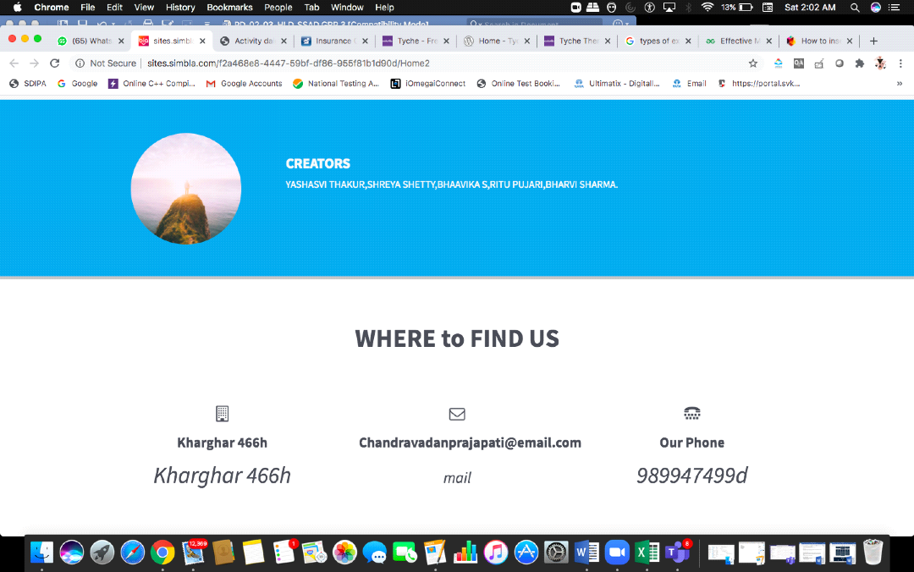

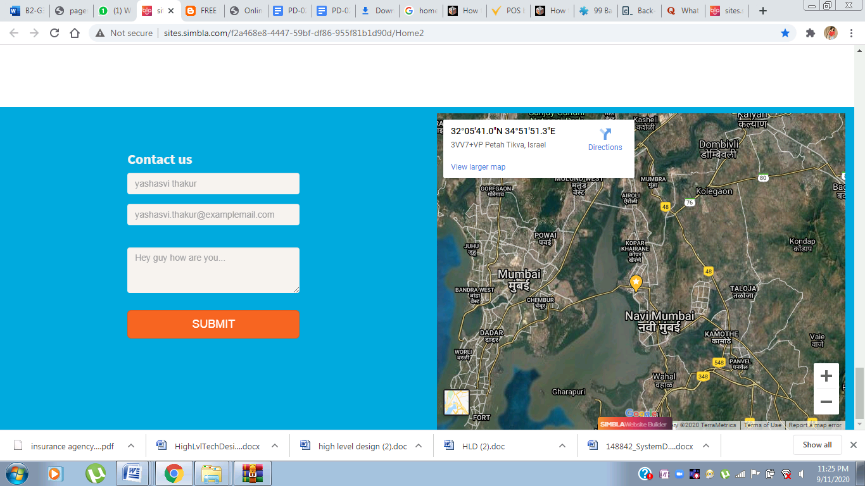

# **Module Specifications**

The modules of the system are as follows:

MODULE 1: Homepage

MODULE 2: Branch Locator

MODULE 3: Customer Profile Page

MODULE 4: Online payment window and confirmation mail

MODULE 5: Calculator

MODULE 6: User Manual

MODULE 7: Customer Services

MODULE 8: Language Switch

MODULE 9: Navigation Bar

The hierarchy of the modules in the software is given below –

|  |  |  |
| --- | --- | --- |
| MODULES | HIGH PRIORITY | LOW PRIORITY |
| MODULE 1: Homepage | ✓ |  |
| MODULE 2: Branch Locator |  | ✓ |
| MODULE 3: Customer Profile Page | ✓ |  |
| MODULE 4: Online payment window and confirmation mail | ✓ |  |
| MODULE 5: Calculator | ✓ |  |
| MODULE 6: User Manual | ✓ |  |
| MODULE 7: Customer Services | ✓ |  |
| MODULE 8: Language Switch | ✓ |  |
| MODULE 9: Navigation Bar | ✓ |  |

## **Module Overview**

MODULE 1 : HOMEPAGE

|  |  |
| --- | --- |
| Functions Provided:- | Logo, navigation bar, login option, customer service etc. can be accessed by the customer. |
| Interfaces to other modules: | Homepage will give the user access to other modules that are branch locator , Navigation bar (search bar) , login page and customer services. |
| Inputs / Outputs: | Once put in the link of the website on the browser, the homepage of the insurance agent portal will be visible and can be accessed |

MODULE 2 : BRANCH LOCATOR

|  |  |
| --- | --- |
| Functions Provided: | Branch locator will help the customer to find the Insurance agent’s office. It can be accessed from the home page. The location will give a direct link for current location and the distance on google map. |
| Interfaces to other modules: | The third party involved is google maps for showing the shortest route between the current location and the nearest branch. |
| Inputs and outputs: | The user will just click on the branch locator and the shortest route with the status of the branch will be provided to the user. |

MODULE 3 : CUSTOMER PROFILE PAGE

|  |  |
| --- | --- |
| Functions Provided: | The customer will be able to download proposal forms, annexure and medical documents .The customer will be able to see his/her details and all the insurances taken in the past/current. |
| Interfaces to other modules: | It will save the user details for other interfaces such as payment window. |
| Inputs and outputs: | The user will provide inputs as mentioned above and as output the user will have a functional account for the website. |

MODULE 4 : ONLINE PAYMENT WINDOW & CONFIRMATION MAIL

|  |  |
| --- | --- |
| Functions Provided | On successful transaction, a digitally signed e-receipt  will be generated and e-mailed to the customer using  3rd party. A confirmation will also be sent if the  customers insurance has been accepted.  (3rd party – Mail Chip) |
| Interfaces to other modules | This will be linked to the payment method choice made in the user login page and send a payment confirmation mail  after the transaction is completed. |
| Inputs | financial transactions and billing occur within the  provider as well as the eligibility, enrollment,  authorizations, claims and payments between  providers and insurers with reporting and notification  between insurers and users. Email address will be  the one registered in the user profile |
| Output | Payment details are required as input and we will  get the policy actively as the output. |

MODULE 5: CALCULATOR

|  |  |
| --- | --- |
| Functions Provided | Loan, premium, emi calculator. The customer can calculate  loans,  premiums and emis very easily. Customer will only have to  input basic information. |
| Interfaces to other modules | This calculation can be saved in the user profile archive. |
| Inputs and outputs | Nominee age , policy rules , term we will get the premium  amount and tax benefit as output. |

MODULE 6 : USER MANUAL

|  |  |
| --- | --- |
| Functions Provided | This will guide the customer through the various  intricacies of a life insurance contract and the  facts the customer must know to make the best out of  his/her life insurance policy. This will be updated  as new policies and changes are made and has been  tested manually. |
| Interfaces to other modules | There will be language switch available for the user  manual |
| Inputs and outputs | Choice of language will be considered as an input  and the translated language will be the output. |

.

MODULE 7 : CUSTOMER SERVICES

|  |  |
| --- | --- |
| Functions Provided | The customer can use this service to check  policy status or to get help using the phone helpline.  This allows the customer to access different  services provided by the agent. |
| Interfaces to other modules | It will be visible on the home page when scrolled  down |

MODULE 8: LANGUAGE SWITCH

|  |  |
| --- | --- |
| Functions Provided | As the website will cater to the people of  Mumbai we don’t want a language barrier.  This feature will translate the entire website  to the language selected by the customer |
| Inputs and outputs | The choice of language will be considered as an  input. |

MODULE 9 : SEARCH BAR

|  |  |
| --- | --- |
| Functions Provided | This feature helps the customer to navigate through the website |
| Interfaces to other modules | It will be having interfaces with all the modules which will appear  as and when searched for |
| Inputs and outputs | It will take the key word written in the search bar by the  user and output will be the interface. |

## **Function Specifications**

MODULE 1 : HOMEPAGE

Functions Provided:- Logo, navigation bar, login option, customer service etc. can be accessed by the customer.

Requirements Addressed:

1. >User must be able to view the Home page of the website.

Ø User must be able to view the list of the added Items (If any) at the home page

Ø User must be able to click at the added Items on the home page

1. >User must be able to view the other modules on the Home page by clicking the respective buttons

Interfaces to other modules: Homepage will give the user access to other modules that are branch locator , Navigation bar (search bar) , login page and customer services.

Logic of the module:

1. User will be able to view log-in page with register new account link
2. User will be able to click onto the register new account link
3. User will be able to enter all the required information on the register new account link
4. User will be able to successfully register a new account
5. User will be able to Log-in with using the same credentials which he used to register an account
6. Once the user logged in, the user will be able to view the home page
7. The user will be able to view the branch locator , logo , customer service
8. The user will be able to click on the ‘Profile’ tab in the bar
9. The user will be able to view his profile with the details he used to register the account
10. The user will be able to click onto the ‘Home’ tab to go back to the Home page

Inputs / Outputs:

Once put in the link of the website on the browser, the homepage of the insurance agent portal will be visible and can be accessed.

List of exceptions that can occur:

1. Slow performance due to server overload (It might show as page not found)
2. This site will not appear from mobile.

MODULE 2 : BRANCH LOCATOR

Functions Provided: Branch locator will help the customer to find the Insurance agent’s office. It can be accessed from the home page. The location will give a direct link for current location and the distance on google map.

Requirements Addressed:

1. User should be able to click the branch locator button on the homepage.
2. User must be able to search nearest branches in Mumbai
3. User should find the shortest route to the branch
4. The current branch status should also be displayed

Interfaces to other modules:

The third party involved is google maps for showing the shortest route between the current location and the nearest branch.

Logic of Module:

1. the user clicks on the branch locator on the website
2. The current location of the user is acquired
3. The branch is located accordingly
4. The shortest route is displayed with the current status of the branch.

Inputs and outputs:

The user will just click on the branch locator and the shortest route with the status of the branch will be provided to the user.

List of exceptions that can occur:

1. If location is not accessible a drop pin will be provided.

MODULE 3 : CUSTOMER PROFILE PAGE

Functions Provided: The customer will be able to download proposal forms, annexure and medical documents .The customer will be able to see his/her details and all the insurances taken in the past/current.

Requirements Addressed:

1. User must be able to view the “User profile by clicking the “User Profile” button
2. User must be able to Sign up for the application to create account
3. User must be able to Sign-In in the application
4. User must be able to view and Edit User’s first Name
5. User must be able to view and Edit User’s Last name
6. User must be able to view and Edit User’s Email ID
7. User must be able to reset their Password
8. User must have a Save button to be able to save their profile information

Interfaces to other modules: It will save the user details for other interfaces such as payment window.

Logic of Module:

1. The module will ask for details such as name, age , location details , registration dates , debt details , choice of payment etc.
2. It will also provide details such as archived purchases , purchased plans and cart details.
3. The user will be locked out if the password has been incorrect in all 3 attempts with a warning.

Inputs and outputs:

The user will provide inputs as mentioned above and as output the user will have a functional account for the website.

List of exceptions:

1. Connection error maybe there
2. There can be a session out.

MODULE 4 : ONLINE PAYMENT WINDOW & CONFIRMATION MAIL

Functions Provided:

Using this feature the customer can pay online for their insurance. It provides for real-time payment of renewal premium-dues through the portal. On successful transaction, a digitally signed e-receipt will be generated and e-mailed to the customer using 3rd party.

On successful transaction, a digitally signed e-receipt will be generated and e-mailed to the customer using 3rd party. A confirmation will also be sent if the customers insurance has been accepted.(3rd party – Mail Chip)

Requirements Addressed:

1. Secure gateway to third party payment module
2. Security to all the banking details

Interfaces to other modules:

This will be linked to the payment method choice made in the user login page and send a payment confirmation mail after the transaction is completed.

Logic of Module:

The payment gateway (PG) initiative is an important component of the offer. It provides for real-time payment of renewal premium-dues through the portal. This functionality is available only to registered customers who have enrolled their policies.

Inputs and outputs:

financial transactions and billing occur within the provider as well as the eligibility, enrollment, authorizations, claims and payments between providers and insurers with reporting and notification between insurers and users.

Payment details are required as input and we will get the policy actively as the output.

Email address will be the one registered in the user profile

List of exceptions:

1. Payment portal may not be available or slow.

MODULE 5: CALCULATOR

Functions Provided:

Loan, premium, emi calculator.

The customer can calculate loans, premiums and emis very easily. Customer will only have to input basic information.

Requirements Addressed:

1. User should be able to click the calculator button on the homepage.
2. User must be able to put in information about the policy

Interfaces to other modules:

This calculation can be saved in the user profile archive.

Logic of Module:

Use this tool to calculate amount of insurance policy. The calculator will require the nominee details to calculate the policy premium etc.

Inputs and outputs:

Nominee age , policy rules , term we will get the premium amount and tax benefit as output.

MODULE 6 : USER MANUAL

Functions Provided:

This will guide the customer through the various intricacies of a life insurance contract and the facts the customer must know to make the best out of his/her life insurance policy. This will be updated as new policies and changes are made and has been tested manually.

Requirements Addressed:

1. There should be proper indexing
2. Proper language support
3. Should be written in Simple language
4. Proper hyperlinks to be provided if required

Interfaces to other modules: There will be language switch available for the user manual

Logic of Module: clicking on hyperlinks provided will direct the user to the necessary information.

It will provide all the insurances and policy guidance with security guidance and some terminologies.

Inputs and outputs:

Choice of language will be considered as an input.

MODULE 7 : CUSTOMER SERVICES

Functions Provided:

The customer can use this service to check policy status or to get help using the phone helpline. This allows the customer to access different services provided by the agent.

Requirements Addressed:

There should be basic facilities available for the user to get in touch with the agent at anytime.

Logic of Module:

There will be a phone number and an email provided which will connect the user directly to the agent

MODULE 8: LANGUAGE SWITCH

Functions Provided:

As the website will cater to the people of Mumbai we don’t want a language barrier. This feature will translate the entire website to the language selected by the customer

Requirements Addressed:

1. The site is geographically based only in Mumbai.
2. The user should be able to view and click the language switch button

Logic of Module:

This option will simply translate the current page into the chosen language for the ease of the user.

Inputs and outputs:

The choice of language will be considered as an input.

MODULE 9 : SEARCH BAR

Functions Provided:

This feature helps the customer to navigate through the website

Requirements Addressed:

The navigation through the site should be easy

Interfaces to other modules:

It will be having interfaces with all the modules which will appear as and when searched for

Logic of Module:

The navigation bar will take the user input (the keyword) and show the respective interface.

Inputs and outputs:

It will take the key word written in the search bar by the user and output will be the interface.

List of exceptions

The site will show error if the keyword is invalid.

## **External Components Used**

1. Google Docs for documentation
2. creately for diagrams